Bushfire Evacuation Modelling Phase 2

Progress Report May2020-March 2021

Vincent Lemiale, Dhirendra Singh, Pawan Deegoda Gamage

Report Number EPXX

March 2021

Prepared for the Victorian Department of Premier and Cabinet

Commercial-in-confidence

Citation

CSIRO (2021). Bushfire Evacuation Modelling Phase 2 - Progress Report January-November 2019. EP203657.

Copyright

© Commonwealth Scientific and Industrial Research Organisation 2020. To the extent permitted by law, all rights are reserved and no part of this publication covered by copyright may be reproduced or copied in any form or by any means except with the written permission of CSIRO.

Important disclaimer

CSIRO advises that the information contained in this publication comprises general statements based on scientific research. The reader is advised and needs to be aware that such information may be incomplete or unable to be used in any specific situation. No reliance or actions must therefore be made on that information without seeking prior expert professional, scientific and technical advice. To the extent permitted by law, CSIRO (including its employees and consultants) excludes all liability to any person for any consequences, including but not limited to all losses, damages, costs, expenses and any other compensation, arising directly or indirectly from using this publication (in part or in whole) and any information or material contained in it.

CSIRO is committed to providing web accessible content wherever possible. If you are having difficulties with accessing this document please contact [csiroenquiries@csiro.au](mailto:csiroenquiries@csiro.au).

Contents

1 Project report summary iii

2 Milestone iv

3 State-wide Evacuability model 1

3.1 Software testing and quality insurance 1

3.2 Evaluating bushfire evacuation models 2

4 Web-based DSS 5

5 Other deliverables 6

5.1 Budget 6

# Project report summary

This report covers the work completed for the Bushfire Evacuation Modelling Phase 2 project in October 2019 to April 2020. In the second part of Phase 2 (October to April 2020) the Data61+RMIT development team focused on the following four components (see [1] for details):

* Web-based Decision Support System: The first version of the web-based DSS was reported, along with an early version of a suitable traffic flow visualisation for the web.
* State-wide Evacuability Model: The purpose of the state-wide evacuability model is to quickly identify potential 'hot spots' across the state where evacuability risk may be high. These areas can then be modelled in more detail using the DSS.
* Community Engagement: Ongoing online discussions were held with Surf Coast and Otways Shires in this period, to decide the streamlined process of data curation which is a requirement from the regions.
* Software quality: For quality assurance, we also invested time in ensuring that the software being built is suitably tested before release. For both the web-based SEM and DSS we incorporated a Continuous Integration pipeline into the software development process, so that every change pushed to the code repositories triggers a new product build on a clean virtual machine and is run against a suite of tests.

In line with the updated project business plan the present report covers the progress made on the development of the Web-Based Decision Support System. Intro to be completed by Vincent (03/21)

# Milestone

Table 1. Milestone for the 1/10/19-31/12/19 period as per the initial agreement.

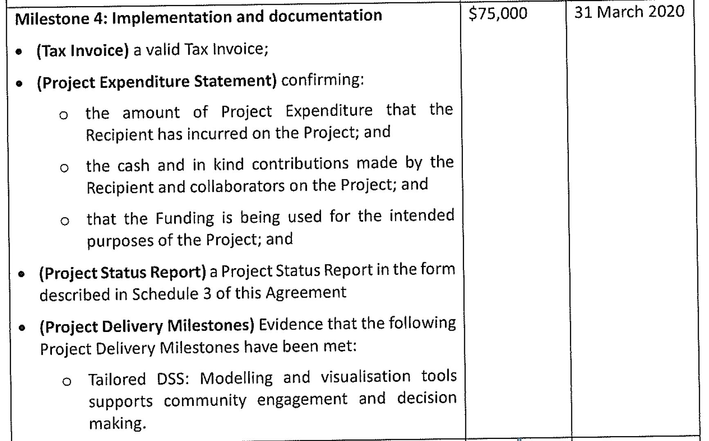

Note that the business plan was updated and provided as part of Milestone 2, see [2]. As part of the business plan update, the milestone deliverables were also updated to reflect agreed changes during the project, most notably the addition of the state-wide evacuation capability as a new deliverable. Table 2 is an excerpt from the updated business plan and shows the new deliverables along with their initial timelines.

Table 2. Clarification of each milestone deliverables based on the updated project business plan.

|  |  |  |  |  |  |
| --- | --- | --- | --- | --- | --- |
| **Milestone** | **Jun-19** | **Sep-19** | **Dec-19** | **Mar-20** | **May-20** |
| Milestone 1: Signed Research Partnership Agreement |  |  |  |  |  |
| Milestone 2: Enhanced (web based) DSS, improvement to the human behaviour modelling (archetypes model) implemented, first prototype of the steady state evacuation tool presented |  |  |  |  |  |
| Milestone 3: Beta version of the steady state evacuation software developed |  |  |  |  |  |
| Milestone 4 : Beta version of the web-based DSS delivered, modelling and visualisation tools supports community engagement and decision making |  |  |  |  |  |
| Milestone 5: Final version of the steady state tool delivered. Final version of the DSS developed and delivered, including demonstrated feature parity with Workspace-based version. |  |  |  |  |  |

# Web-based DSS

## Overview

## Web Application home page

* Create a new scenario.
* View saved scenario.
* Add layers to the map and view layers.
* Zoom in/out and rotate map.

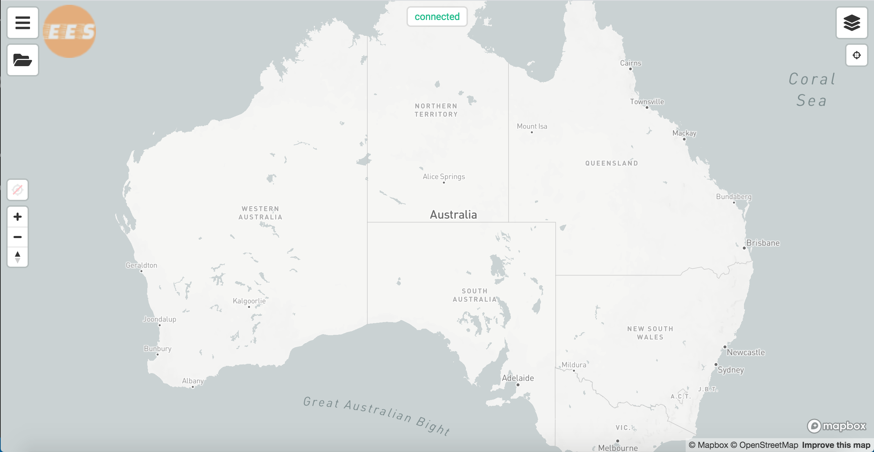

2

1

4

3

## New scenario/job creation

|  |  |
| --- | --- |
| Log in to the Home page, and Click on **Hamburger** icon on top left corner.  Click on **Job** from the list. |  |
| Next panel will list options to create a new scenario and load existing scenarios.  Select **New** from the list  This will open a form to enter new job details as shown in the image. |  |
| Enter scenario details (Name, Type) and click **Create Job**. |  |
| Map view after the scenario creation ->  Selecting a region from the list will trigger a zoom-in to the selected region on the Map. |  |

## Scenario setup

Required inputs;

1. Fire layer
2. Population layer
3. Evacuation plan (Message list)

### Adding Fire and Population layer to the Map

|  |  |
| --- | --- |
| Click on any preferred region |  |
| Under **scenario settings**, select a Fire layer from the list.  **Note**: This will only list down fires in the selected region. |  |
| Select a Population layer from the list  **Note**: This will only list down population layers in the selected region. |  |
| Map view after both Fire and Population layers added -> |  |
| Use time slider to filter **Fire** and **Population** layers based on time. |  |

### Adding evacuation messages

|  |  |
| --- | --- |
| Enable evacuation zones by clicking on “show evacuation zones” under **scenario settings**    This will generate the **SA1** zone layer for selected region |  |
| Click on any zone to add a message or use multiple zone selection (As pointed in the image) to add messages to multiple zones at once. |  |
| **Evacuation plan** will be listed in side menu as shown in the image -> |  |

## Scenario run/execution

|  |  |
| --- | --- |
| Click on “**Play button**” in top left corner to run the simulation. |  |
| Job progress will be displayed as follows   1. Job starting |  |
| 1. Job running |  |

## Simulation outputs

|  |  |
| --- | --- |
| After a successful scenario run, the application will create below output layers.   * Car simulation layer * Road Network Traffic layer * Absolute Population layer * Fire Layer with burnt percentage.   Map view after the scenario run complete -> |  |
| Cars simulation ->  Click on play (bottom-middle) to start simulation |  |
| All other outputs will be listed in the sidebar.  Click on **Outputs** in toggle button(bottom-left) to generate these layers.  Output metric 1 – Road Network Traffic -> |  |
| Output metric 2 - Absolute Population grid layer -> |  |
| Output metric 3 - Percentage of Area Burnt in each grid cell (0 to 1) -> |  |

# Comparing Web-based to Standalone DSS

The following table compares the features available in the new Web-based DSS to the Standalone DSS prototype produced for the Great Ocean Road region[1].

|  |  |  |
| --- | --- | --- |
| **Feature** | **Web-based DSS** | **Standalone DSS** |
| Operating system support | Available for Windows only | Available on all operating systems |
| Device support | Available on Windows desktop machines only | Available on all internet-enabled desktops and mobile devices |
| Installation and maintenance | Software and subsequent updates manually installed on user machines | Software automatically installed and updated on offering web server |
| Human behaviour model | V1 co-developed with domain experts | V2 improved to include self-evacuation archetypes |
| Traffic Model | MATSim V11 (2018) | MATSim V13 Snapshot (2020) |
| Regions supported | Surf Coast Shire VIC only | Surf Coast Shire VIC and Mount Alexander Shire VIC are initially supported. New regions can be added as needed. |
| Phoenix RapidFire support | Shows Isochrome output; hazard analysis produces colour map to show intersection of fire front with roads | Shows more accurate raster grid output together with intensity colouring; time slider gives improved understanding of timing and intensity of intersection with full landscape including roads |
| Evacuation plan support | Allows an evacuation plan to be constructed by selecting zones on the map and configuring timed messages to be sent to agents in those zones during the simulation | Ditto |
| Outputs supported | Driving vehicles playback, Zone-based heatmaps, Road-network links based heatmap, Charts, Tables (export) | Driving vehicles playback, Zone-based heatmaps, Road-network links based heatmap, Charts (not available yet), Tables (export), Conditional layers (on-the-fly analysis) |

# Other deliverables

## Budget

The total funding for this project is $500,000 split into five instalments according to Schedule 2 of the funding agreement. Co-investment has been made by the CSIRO through in-kind contribution for a total project budget of $688,000. Table 3 report on the total project expenditure for the period October 2019 - April 2020. The full expenditure statement has been provided as a separate PDF document to DPC.

Table 3. Project expenditure October 2019-April 2020

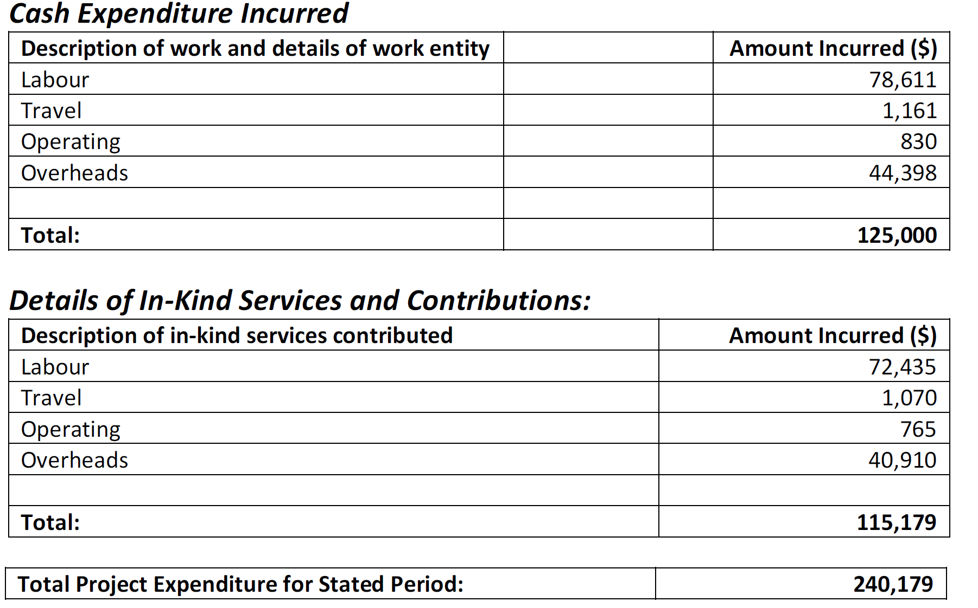

References

[1] V. Lemiale, D. Singh, L. Marquez, and V. Dabre, “Bushfire evacuation modelling Phase 2 Progress report October 2019-April 2020,” CSIRO Data61, Clayton, Australia, EP203657, 2020.

[2] V. Lemiale, D. Singh, N. Forbes-Smith, A. Young, M. Prakash, and J. Hilton, “Bushfire evacuation modelling Phase 2 Progress report January-November 2019,” CSIRO Data61, Clayton, Australia, EP198530, 2019.

|  |  |  |
| --- | --- | --- |
| CONTACT US  t 1300 363 400  +61 3 9545 2176  e csiroenquiries@csiro.au  w www.data61.csiro.au  we do the extraordinary every day  We innovate for tomorrow and help improve today – for our customers,  all Australians and the world.  WE IMAGINE WE COLLABORATE WE INNOVATE |  | For further information  Dr Vincent Lemiale Team Leader  t +61 3 9545 2980  e vincent.lemiale@csiro.au  w www.data61.csiro.au  www.data61.csiro.au |

1. **Great Ocean Road Bushfire Evacuation Modelling Decision Support System** Final Report v1.1, 30 April 2019, Callum Fairnie,  
   Vincent Lemiale, Leorey Marquez, Rajesh Subramanian, Dhirendra Singh, Joel Robertson